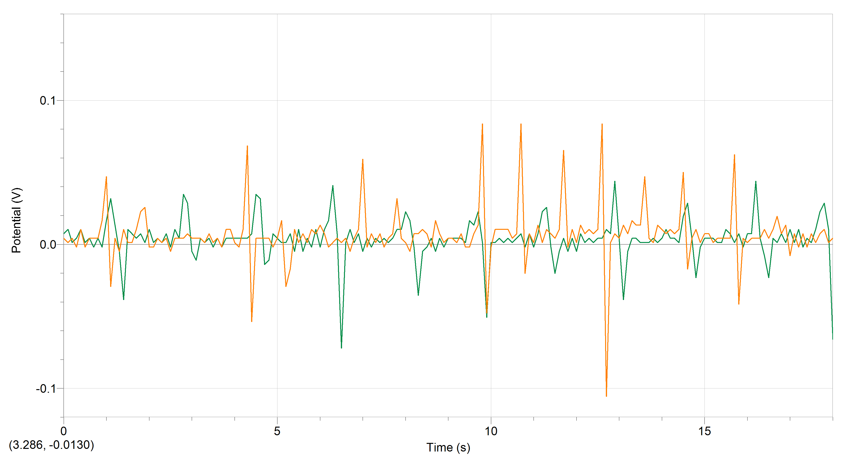

Test A (Part 1: Positive) Green = slow, Orange = fast

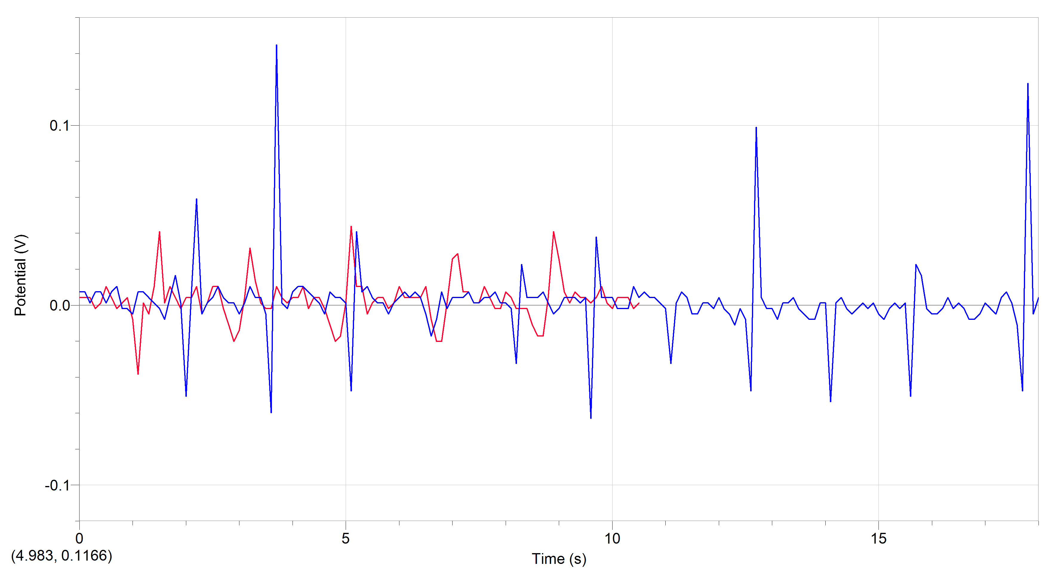

Test A (Part 2: Negative) Red = slow, Blue = fast

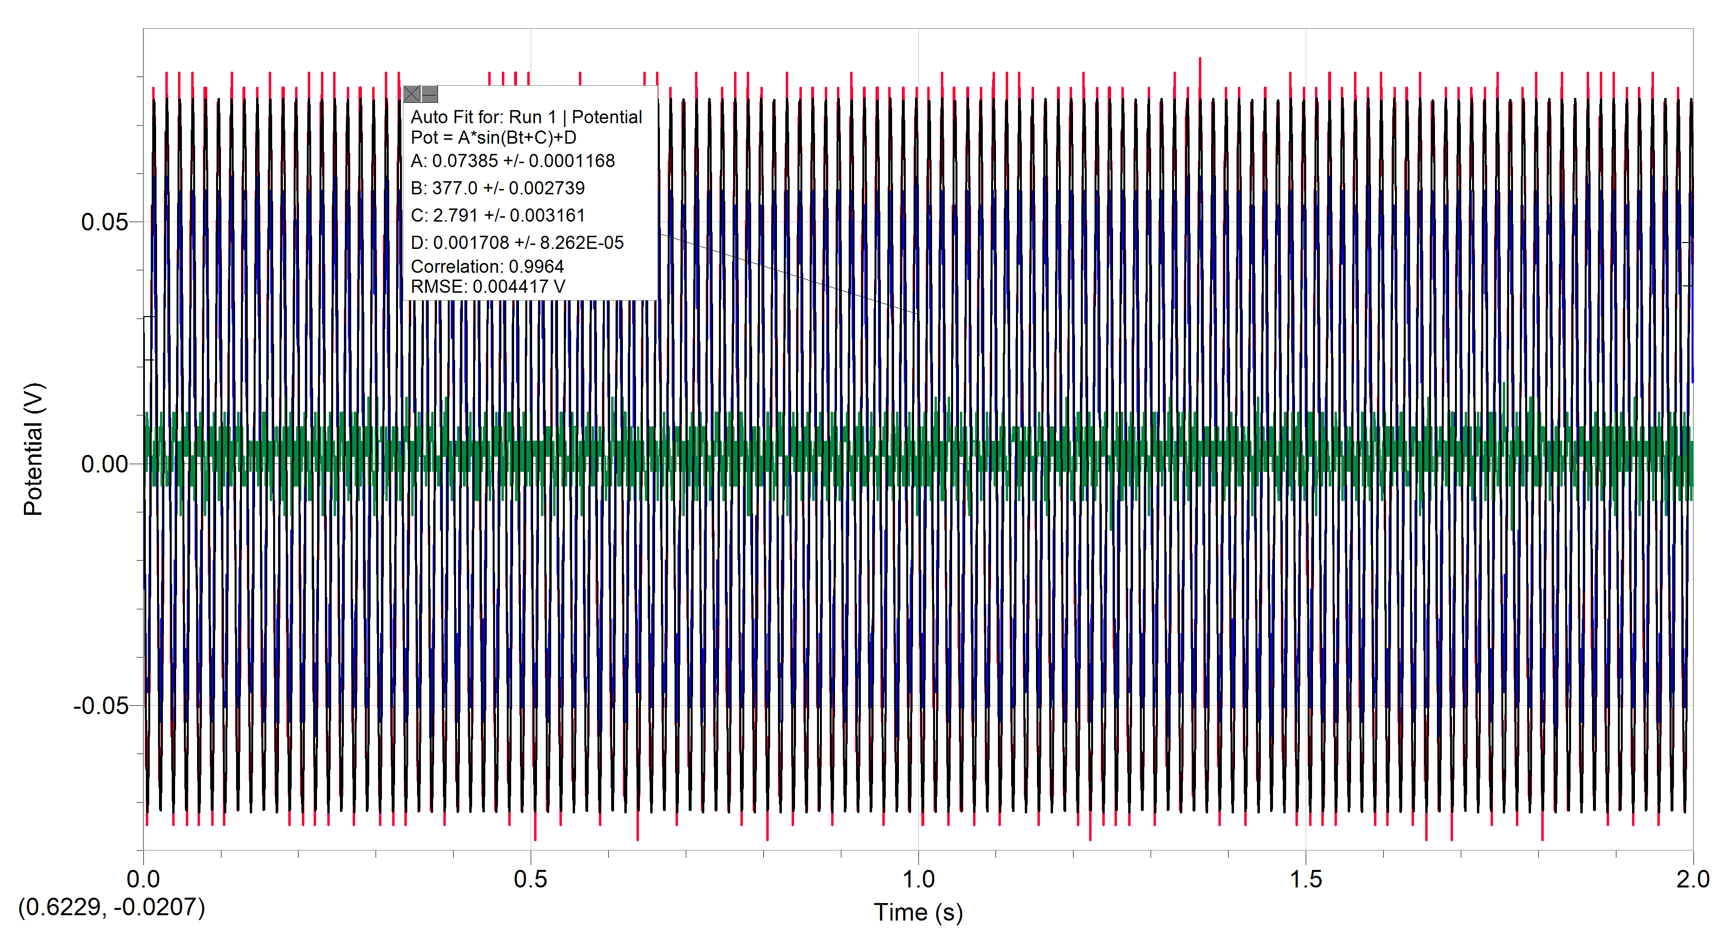

Test B